## 

## ****UPI PAYMENTS APPS REVIEW****

## Report

Submitted in the partial fulfillment of the requirements for the award of the degree of

# Bachelor of Technology in

Department of Computer Science and Engineering

By

Anil Kumar (2010030015)

B. Sai Rishal (2010030020)

Dileep Sai (2010030288)

Madhu sai (2010030090

Jashwanth Reddy (2010039002)

under the supervision of

# **Dr. Anal Paul**



Department of Computer Science and Engineering

K L University Hyderabad,

Aziz Nagar, Moinabad Road, Hyderabad – 500 075, Telangana, India.

March, 2022

**Declaration**

The Social Internship Report entitled “**UPI PAYMENTS APPS REVIEW**” is a record of bonafide work of Anil (2010030090), Sai Rishal (20100030020), Dileep sai (2010030288), Madhu sai (2010030090), Jashwanth Reddy (2010039002) submitted in partial fulfillment for the award of B.Tech in the Department of Computer Science and Engineering to the K L University, Hyderabad. The results embodied in this report have not been copied from any other Departments/ University/ Institute.

**Certificate**

This is to certify that the Social Internship Report entitled

“**UPI PAYMENTS APPS REVIEW**” is being submitted

Anil (2010030090), Sai Rishal (20100030020), Dileep sai (2010030288), Madhu sai (2010030090), Jashwanth Reddy (2010039002) submitted in partial fulfillment for the award of B.Tech in CSE to the K L University, Hyderabad is a record of bonafide work carried out under our guidance and supervision.

The results embodied in this report have not been copied from any other departments/ University/Institute.

## Signature of the Supervisor

Mr. Anal Paul

## Signature of the HOD Signature of the External Examiner

**ACKNOWLEDGEMENT**

First and foremost, we thank the lord almighty for all his grace & mercy showered upon us, for completing this Social Internship successfully.

We take grateful opportunity to thank our beloved Founder and Chairman who has given constant encouragement during our course and motivated us to do this Social Internship. We are grateful to our Principal **Dr. L. Koteswara Rao** who has been constantly bearing the torch for all the curricular activities undertaken by us.

We pay our grateful acknowledgement & sincere thanks to our Head of the Department **Dr. Chiranjeevi Manike** for his exemplary guidance, monitoring, and constant encouragement throughout the course. We thank Mr. Anal Paul of our department who has supported throughout this Social Internship holding a position of supervisor.

We whole heartedly thank all the teaching and non-teaching staff of our department without whom we won’t have made this Social Internship a reality. We would like to extend our sincere thanks especially to our parent, our family members and friends who have supported us to make this project a grand success.

**ABSTRACT**

The use of E-payment system is increasing at a very fast rate. Day by day the

numbers of users are moving towards online payment systems instead of using

plastic money like cash etc. Making online transactions is very convenient and time

saving. People can pay online not only for shopping but also for different purposes

as many different apps are available that offers many services to the users. This

paper studies the reasons of increasing popularity and use of payment apps by the

people of India for making payments online and the continuous growth of these

payment apps in India. The authors of this paper analysed three most popular American Journal of Industrial and Business Management, 2017, 7, 1174-1191

http://www.scirp.org/journal/ajibm

ISSN Online: 2164-5175

ISSN Print: 2164-5167

DOI:

10.4236/ajibm.2017.710084 Oct. 26, 2017 1174 American Journal of Industrial and Business Management

Unified Payment Interface—An Advancement

in Payment Systems

Rahul Gochhwal

Indian Institute of Management, Calcutta, India

Abstract

This paper studies Unified Payment Interface (UPI), a new age payment sy

s-

tem introduced in India by National Payment Corporation of India. Unified

Payment Interface is a mobile centric, real time

interbank payment system

which has the potential to transform and universalize digital payments in I

n-

dia. The paper traces the evolution of payments systems in India and e

x-

amines in detail the technology behind Unified Payment Interface focusing on

its architecture and security systems through empirical and theoretical liter

a-

ture review. UPI is a significant advancement as compared to extant payment

system in terms of cost, ease of use for consumers, settlement times and sec

u-

rity and has witnessed good user

adoption. Its modular API based architecture

will enable development of innovative solutions for consumers and busines

s-

es. UPI is currently in its infancy stage and development of merchant centric

UPI solutions will greatly increase the user adoption. UPI

can help bring a

large part of the population within the ambit of digital economy and can be a

great tool for financial inclusion in India.

Keywords

Mobile Payments, Real Time Payments, Unified Payment Interface, Digital

Payments

payment Apps used in India namely, Google Pay, PhonePe and Paytm. American Journal of Industrial and Business Management, 2017, 7, 1174-1191

http://www.scirp.org/journal/ajibm

ISSN Online: 2164-5175

ISSN Print: 2164-5167

DOI:

10.4236/ajibm.2017.710084 Oct. 26, 2017 1174 American Journal of Industrial and Business Management

Unified Payment Interface—An Advancement

in Payment Systems

Rahul Gochhwal

Indian Institute of Management, Calcutta, India

Abstract

This paper studies Unified Payment Interface (UPI), a new age payment sy

s-

tem introduced in India by National Payment Corporation of India. Unified

Payment Interface is a mobile centric, real time

interbank payment system

which has the potential to transform and universalize digital payments in I

n-

dia. The paper traces the evolution of payments systems in India and e

x-

amines in detail the technology behind Unified Payment Interface focusing on

its architecture and security systems through empirical and theoretical liter

a-

ture review. UPI is a significant advancement as compared to extant payment

system in terms of cost, ease of use for consumers, settlement times and sec

u-

rity and has witnessed good user

adoption. Its modular API based architecture

will enable development of innovative solutions for consumers and busines

s-

es. UPI is currently in its infancy stage and development of merchant centric

UPI solutions will greatly increase the user adoption. UPI

can help bring a

large part of the population within the ambit of digital economy and can be a

great tool for financial inclusion in India.

Keywords

Mobile Payments, Real Time Payments, Unified Payment Interface, Digital

Payments

**TABLE OF CONTENTS**

|  |  |
| --- | --- |
| S.No | Topic |
| 1 | Introduction |
| 2 | Literature Survey |
| 3 | Methodology and Implementation |
| 4 | Output |
| 5 | Results Discussion |
| 6 | Conclusion |
| 7 | Future Work |
| 8 | Social Contribution |
| 9 | References |

**Introduction**

* Unified Payments Interface (UPI) is a system that powers multiple bank accounts into a single mobile application (of any participating bank), merging several banking features, seamless fund routing & merchant payments into one hood.
* It also caters to the “Peer to Peer” collect request which can be scheduled and paid as per requirement and convenience.
* Looking forward, COVID-19 has provided a new opportunity for UPI and digital banking in general. India wants to decrease the amount of physical currency in circulation, and the pandemic has shown many people the virtues of online banking.
* For example, young adults wary of infecting their older parents have helped an older generation get on UPI and utilize everything it has to offer.
* UPI’s recent boom focuses back to the platform’s original goal: creating an even playing field for all people, regardless of background or socioeconomic status. In 10 or 20 years, it would not be surprising to see all banking conducted virtually.
* Therefore, it is crucial to create a solid infrastructure that eliminates a system of preferential treatment based on wealth. UPI is helping to fight that fight.

**Literature Survey**

(Surabhi Agarwal,2018), The government feels that incentives through the merchants could drive the usage higher than just peer to peer payments. Incentives offered in the scheme include ₹51 cashback on a minimum transaction value of just ₹1 for the first time users and ₹25 cashback per transactions for 20 unique transactions in a month,forconsumers,while merchants could receive cashback of up to 10% of a transaction and upto₹1000 per month.

(Salil Panchal and Manu Balachandran, 2018),UPI's success is a proof that India is moving mountains to usher in a less-cash economy. But the scope of BHIM must be widened. HIM should add more categories to the payment application for user engagement is the ―Refined and Finished‖ product of IMPS and it is forecasted that at some International Journal for Research in Engineering Application & Management (IJREAM) ISSN : 2454-9150 Vol-04, Issue-07, Oct 2018 353 | IJREAMV04I0743161 DOI : 10.18231/2454-9150.2018.0969 © 2018, IJREAM All Rights Reserved. stage, it could get merged with the NEFT system, operated under RBI guidelines.

(Sais Desai, NipunJasuja and Piyush Khandekar,2017), UPI leads to a unified, secure, ―form independent‖, and inexpensive user interface for payments. Before UPI, the only payments system that exhibited this behavior was cold, hard cash. And in a society where 95% of transaction are still based on cash, digital cash will be adopted only if it provides the same level of comfort. UPI takes status quo rails, status quo infrastructure and binds them all together. Such an interoperable system lays the foundation for the conversion of physical cash to digital cash at will, making the need for physical cash obsolete. UPI has the potential to completely transform the face of the nation.

(Roshna Thomas and Dr. Abhijeet Chatterjee,2017), UPI is indeed a revolution in the Indian economy. However it's success depends on various factors. Financial inclusion or access to banking services is a prerequisite for growth of UPI which is being facilitated by PMJDY and the increasing smartphone penetration. The ability of banks to capitalize on customer faith, effectively promoting UPI and facing competition from mobile wallets will also be the deciding factors. If the banks fail to develop an effective front end platform then UPI could fail.

(ShrutiArcot Kesavan,2018), With the coming up of UPI 2.0 on August 16,2018 more number of merchant transactions will happen which were hitherto restricted mainly to peer-to-peer(P2P). UPI transactions are expected to account for 50% of digital transactions by March, 2023. It is expected to grow at 90% per annum over the next 5 years to $400-450 Billion a year

**Implementation code**

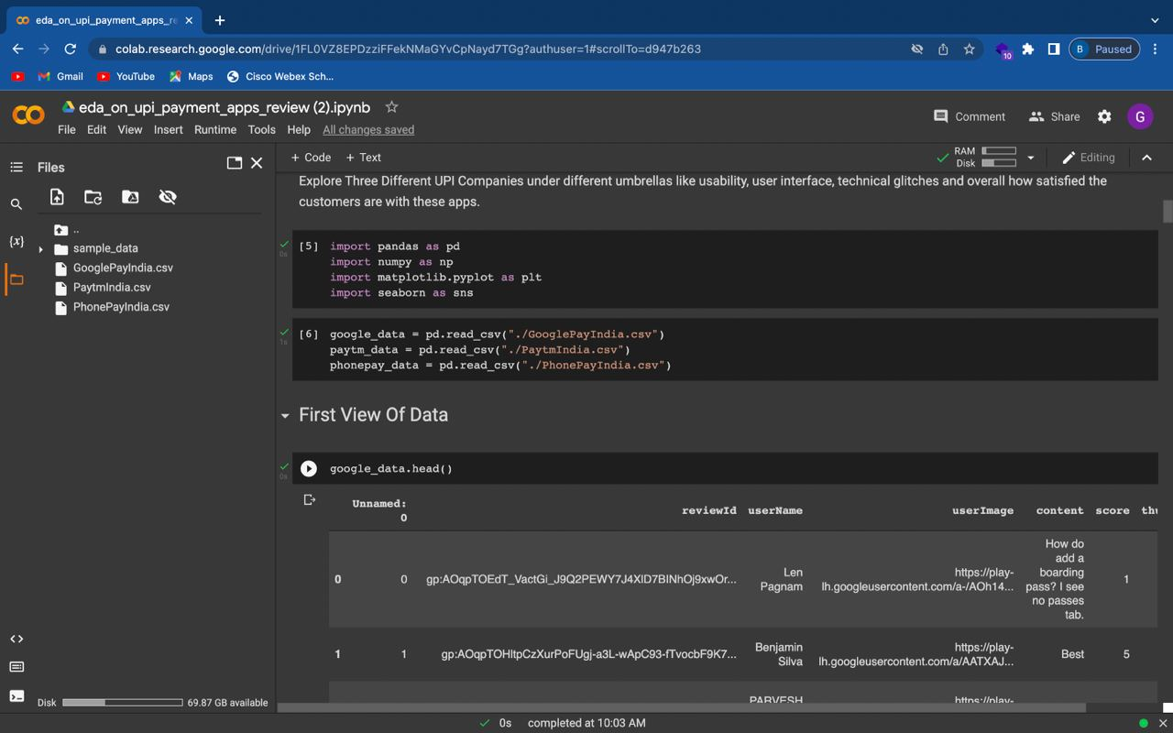

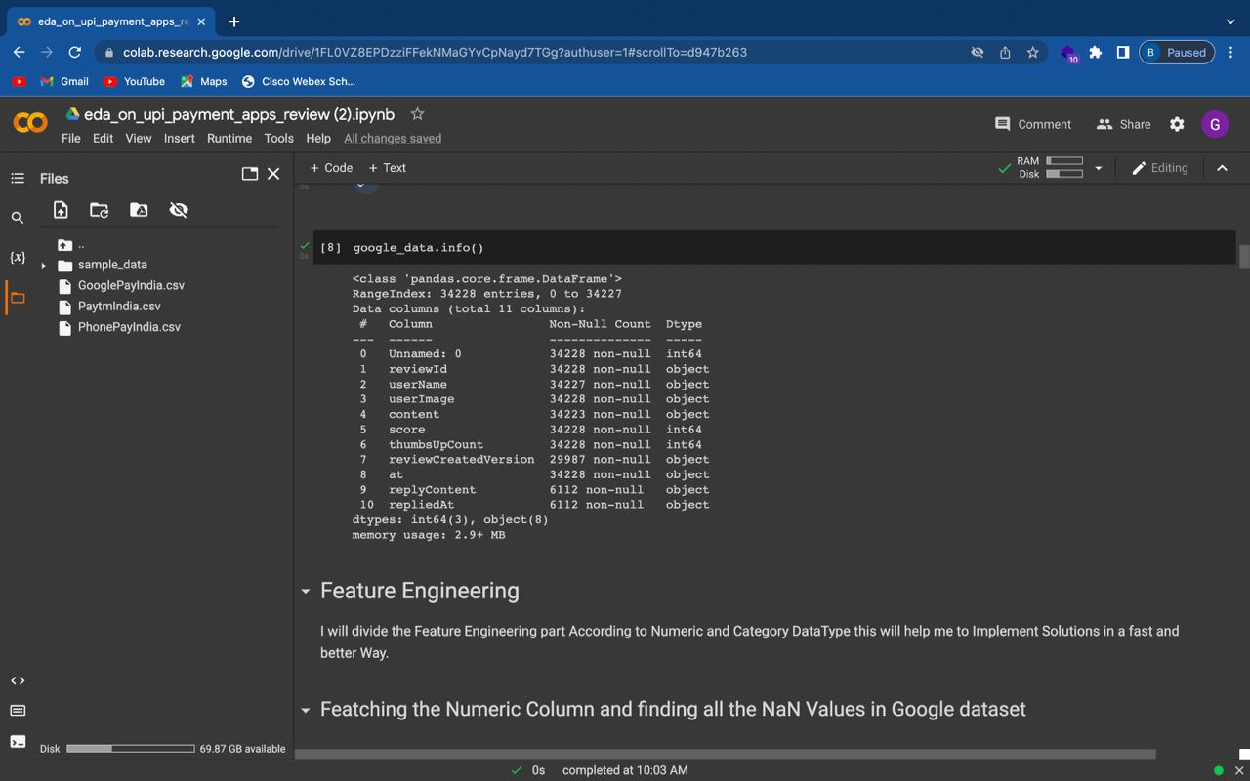

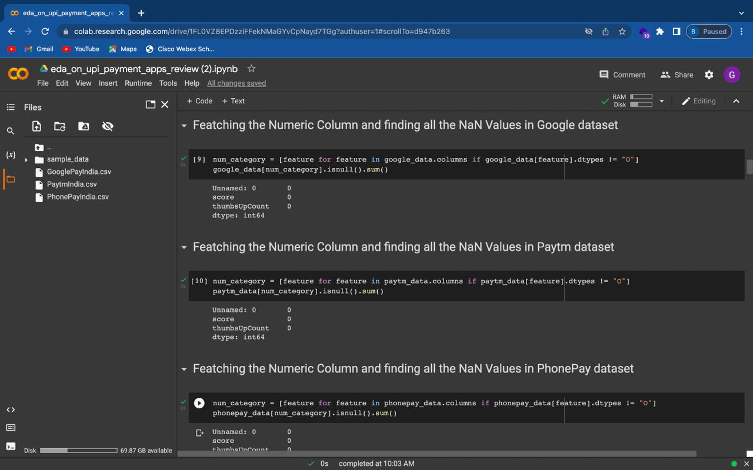

**Results output:**

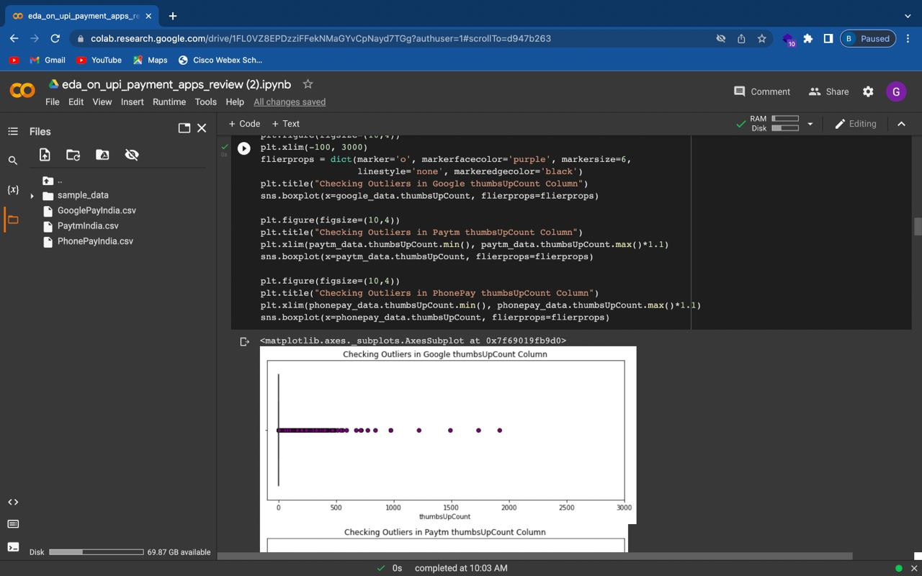

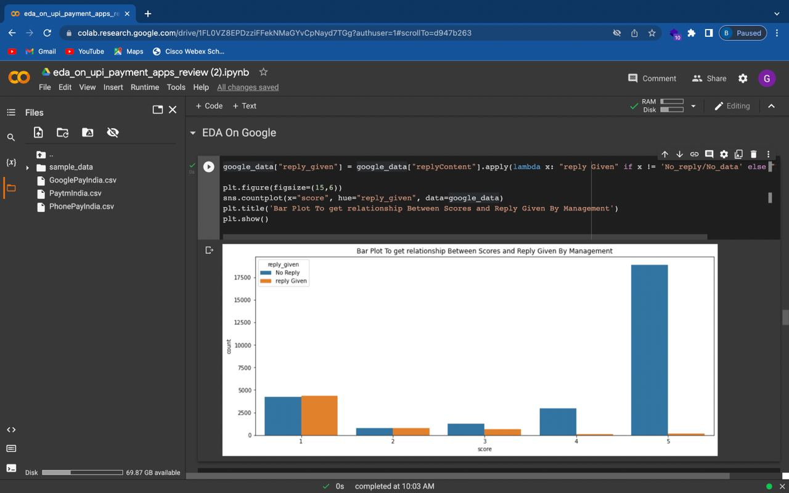

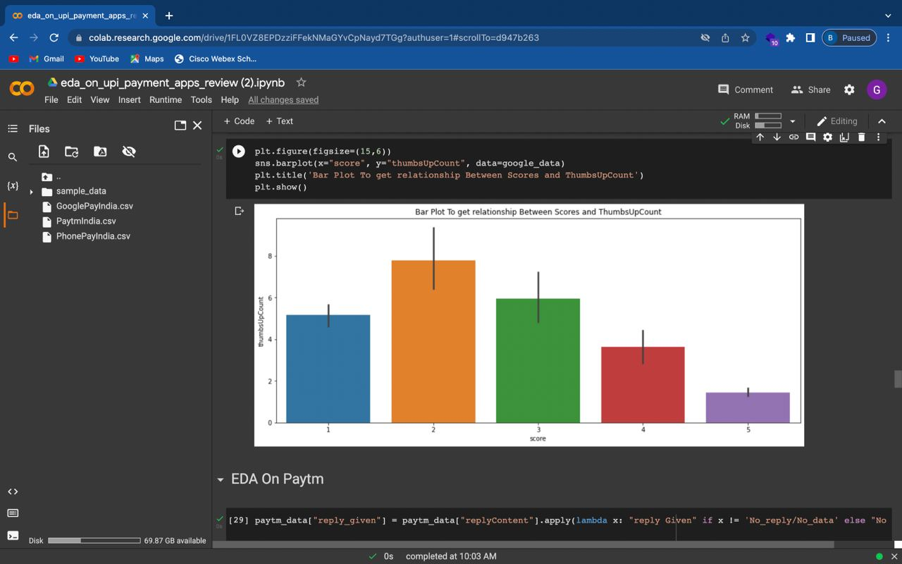

**Implementation Steps**

Step 1:

Download and install the app

Step 2:

Set login and create virtual address

Step 3:

Add your bank accounts

Step 4:

Set your M-pin: As with conventional banking apps, set a unique M-pin to start transacting

Step 5:

Start transacting: With above formalities cleared, step into the UPI future.

**Conclusion and Future Scope**

* Feature engineering is the process of using domain knowledge to extract features from raw data
* The motivation is to use these extra features to improve the quality of results from a machine learning process, compared with supplying only the raw data to the machine learning process
* UPI is till date the biggest revolution in the digital payments sector in India.
* During the previous financial year (2017-18), 915.23 million transactions worth 1098.32 billion occurred through UPI.
* During the first quarter of the financial year (2018-19), 625.93 million transactions worth 1011.44 billion occurred through UPI.
* The value of transactions last year is almost equal to the value of transactions that have occurred in the first quarter this year, which implies that UPI is being increasingly adopted by the masses and it is undeniably the game changer in the digital payments industry because of the level of convenience and lowcost services that it provides.
* UPI will soon make smartphones the primary device for all payments and bring an enormous transformation in the digital payments sector.

**References**

[1] RBI Annual Report,2016-17, [www.rbi.org.in](http://www.rbi.org.in)

[2] UPI Product Review, NPCI , <https://npci.org.in/>

[3] How is UPI better than IMPS, <https://yourstory.com/mystory/aec4c02249-how-upi-isbetter-than/amp>

[4] Your guide to UPI — the world’s most advanced payments system,https://medium.com/whartonfintech/your-guide-to-upi-the-worlds-most-advancedpayments-system-b4e0b372bf0b

[5] How different is the Unified Payment Interface(UPI) from mobile wallets?

[6] <https://www.quora.com/How-different-is-the-UnifiedPayment-Interface-UPI-from-mobile-wallets>

[7] UPI 2.0, BHIM and the new shape of payments,ForbesIndia,http://www.forbesindia.com/article/fin tech-supermarket/upi-2.0-bhim-and-the-new-shape-ofpayments/51195/1

[8] A Fresh Scheme via Merchants to Help BHIM Gain Currency Again, (Saurabhi Agarwal,28 Aug 2018) Economic Times

[9] States to test GST Cashback for Rupay, BHIM App payments (5 Aug 2018), Economic Times

[10] The Future of UPI Payments in India,(3 Sep,2018) <https://www.instamojo.com/blog/future-of-upi-paymentsindia-growth-expect/>

[11] Cash deals cost 1.7% of GDP: Visa, <https://www.businessstandard.com/article/economy-policy/cash-deals-cost-1-7-ofgdp-visa-116100500617_1.html>

[12] UPI: 5-step process to get you started ,https://www.businessstandard.com/article/finance/upi-5-step-process-to-get-youstarted-116082600180_1.html

[13] Unified Payment Interface (UPI): A Catalyst Tool Supporting Digitalization – Utility, Prospects & Issues. Roshna Thomas and Dr. Abhijeet Chatterjee, International Journal of Innovative Research and Advanced Studies (IJIRAS) Volume 4 Issue 2, February 2017.